Electricity in the home
A battery produces direct current (_ _) while the electricity to supplied to our homes (called mains electricity) is alternating current or _ _.
In direct current the electrons flow from the ___________(-) terminal to the _________ (+) terminal. With AC the electrons jiggle back and forwards through the wire. Each jiggling electron passes its energy onto the ________ electron.

The elelctricity in our home is a large __________ circuit. Each appliance is on its own ________ with its own ____________.
The electrical cables are made of ________ separate wires.

3 pin plug
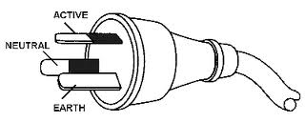
Draw the diagram and colour each pin the appropriate colour.

The live wire is called __________ and is coloured ___. The neutral wire is coloured ___________.
The earth wire is a safety feature it is usually _______ or __________.
Electricity supplied to homes in Australia is supplied at ______V which is enough to kill a person.
In case of an accident the electricity will flow through the ___________ wire instead of an appliance or a person.
Electrical Safety
When electricity flows through a wire it gets ________. If the wires got too hot they could _______ their __________ coating or catch _________.
Appliances that are not working properly can cause too much _____________ to flow through _______ _________ which can also cause a fire.

Fuses & Circuit Breakers
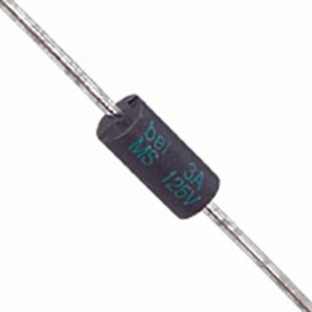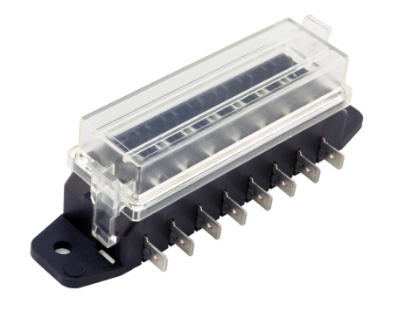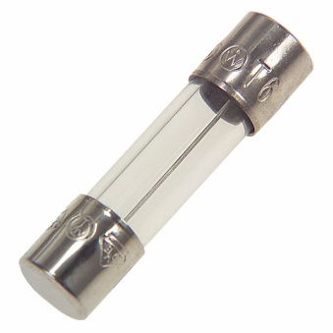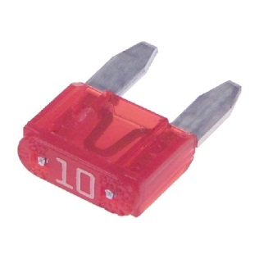
Fuses have a higher ________ with a lower _________ _________ than the other __________ wiring in the house. If too much __________ flows the wire in the fuse will __________ before any of the other wiring. Once the wire in the fuse melts the ____________ is ___________ and no electricity will flow. We say the fuse has __________.
When a fuse blows you should check all your electrical appliances before replacing the fuse. You also need to make sure the correct amp fuse wire is used.
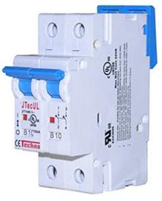
A circuit breaker does the same job as a fuse but it does it electronically. The circuit breaker will _______ when it detects large ____________.

Safety Switch / RCD
A safety switch monitors how much _________ is flowing through the ______________. If the amount coming in is not the same as the amount coming _________ of the house then there must be a ____________. The switch will then ___________ the circuit.
Some powerboards have their own safety switch. 

